Jacqueline Rios

U90674714

**Semester Project: High-fidelity Wireframes**

**Instructions:**

* Students will prepare high-fidelity versions of your low-fidelity wireframes, (6-8 wireframes 1 wireframe per page)
* The wireframes should represent the page in its entirety, including elements revealed by scrolling, swiping, or rolling over page elements.
* These elements can be depicted as you choose, in a format appropriate to what you are representing (e.g., by having two versions of the wireframe, one showing the default size and view of the page, and one showing the elements revealed by swiping, scrolling, etc.).
* Remember, as per our readings, **high-fidelity wireframes** are highly detailed. Please provide an in-depth look at the details that are missing in your low-fidelity wireframes. You are required to use Balsamiq, Visio, or Lucid Chart to make mockups with these tools.

**Homepage Wireframe:**

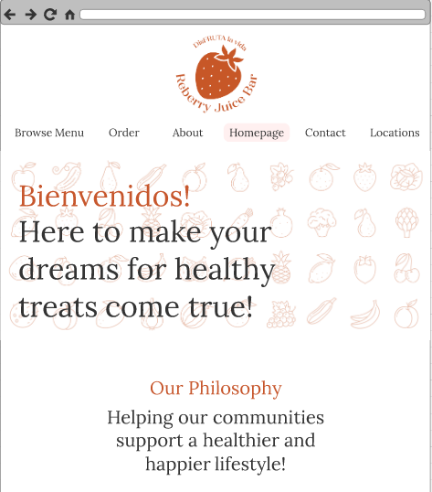

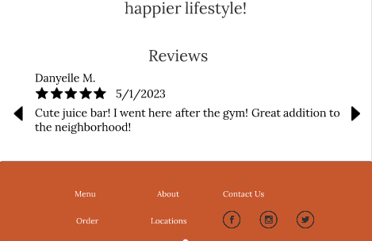

**Browse Menu Wireframe:**

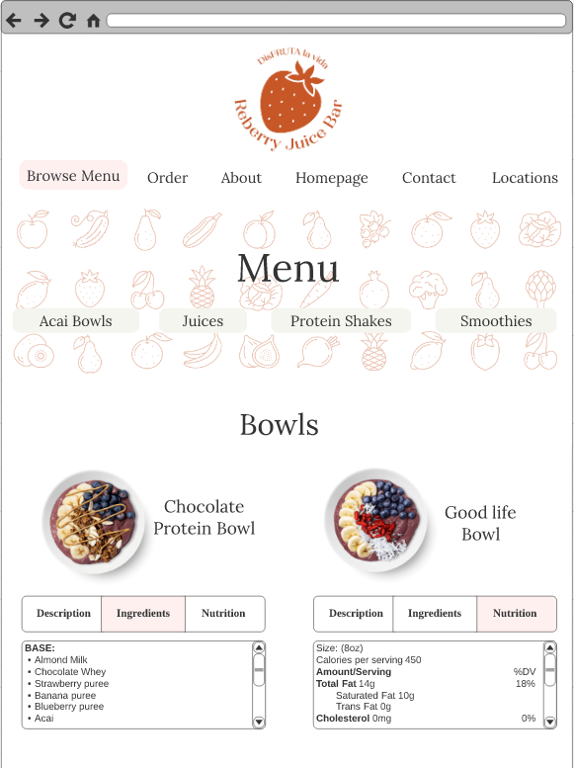

**Browse Menu Wireframe :**

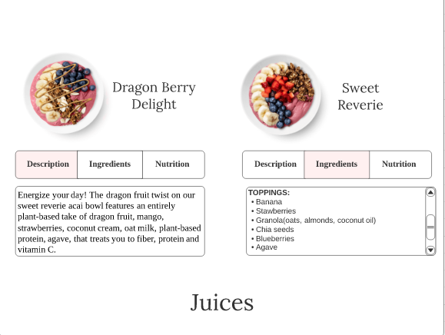

**Rewards Account Wireframe:**

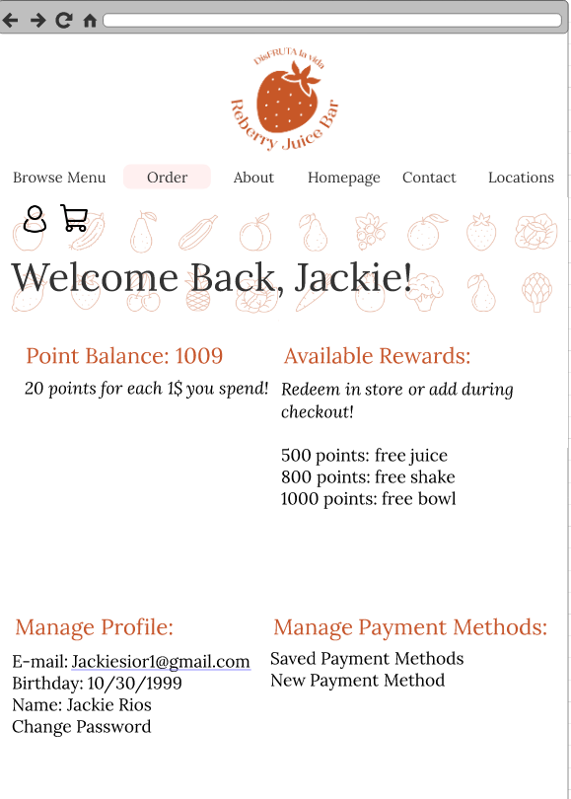

**Rewards account Wireframe:**

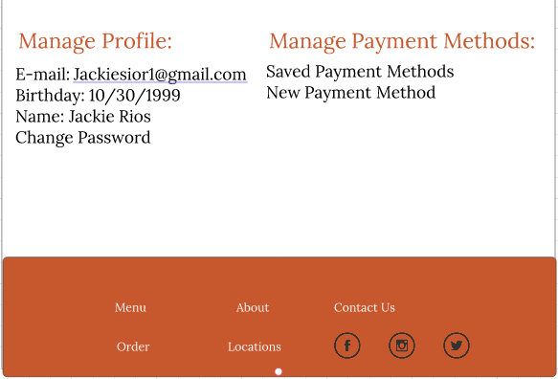

**Order Menu Wireframe :**

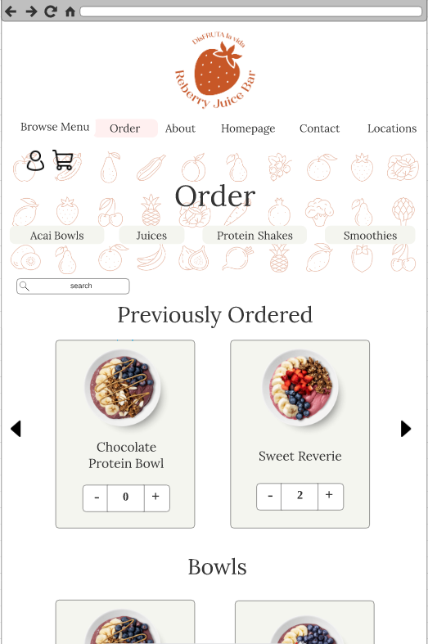

Bottom of window.

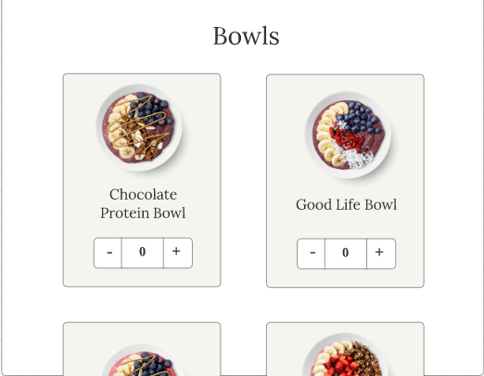

Can keep scrolling to view rest of menu items.

**Locations Wireframe:**

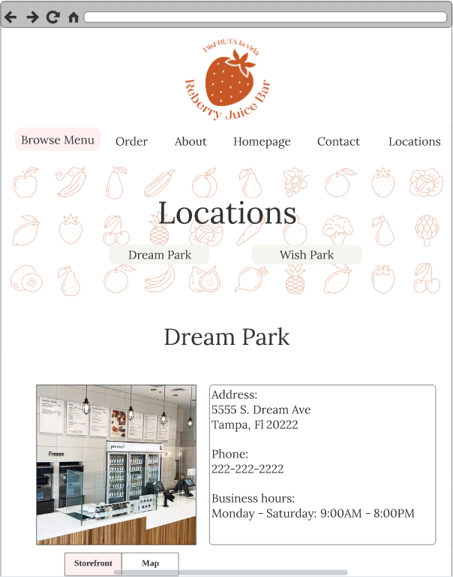

**Locations Wireframe:**

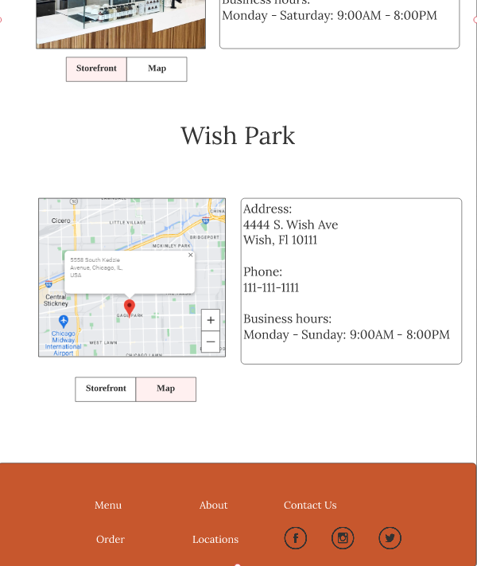

**Contact Wireframe:**

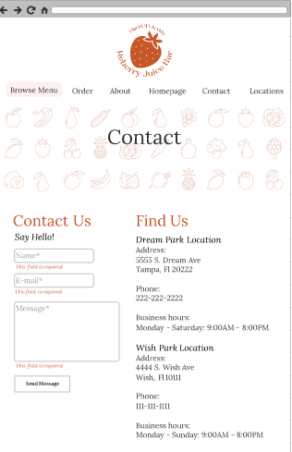

**Contact Wireframe:**

